Working in the Cloud

with ClearMedia Academy

ClearMedia F-Secure deployment

**Disclaimer**:

By using the ClearMedia vCloud Director templates, you can greatly reduce the amount of time needed to deploy new VMs. These templates have been configured with the best practices in mind, to assure optimal stability and performance. Although use of the template is not compulsory, it is recommended!

In-Depth explanation and step-by-step procedures

* Request the F-Secure Server protection license via the ClearMedia support.
* Request a key for x servers, corresponding to the number of RDS servers and mentioning the vApp name.
* If you do not have an account on the ClearMedia F-Secure PSB portal (the place where the servers and licenses are managed by the partner), you will receive instructions from the ClearMedia support to register this.
* Once registered, open the registration email which contains the credentials that you need to login to the F-Secure PSB portal.
* Login to the portal [**https://elements.f-secure.com/apps/psb/**](https://elements.f-secure.com/apps/psb/) and go to the Download tab.
* Find “Computer Protection | Server Protection & ….” on the Download page.
* Download either EXE or MSI version.

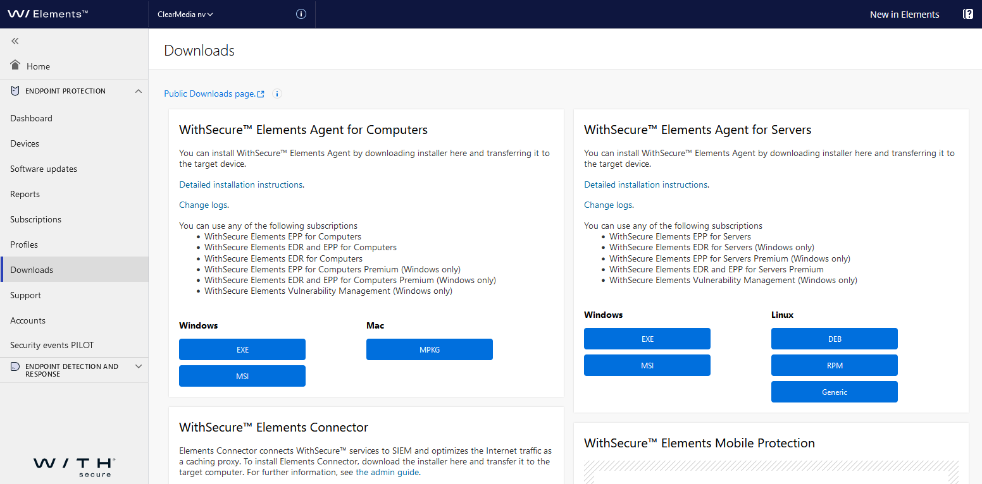

* Or use the following link to download the software directly:

<https://download.sp.f-secure.com/PSB/latest/installer/OfflineInstallerCP-PSB4.msi>

* Install the software on the server.
* At a certain point it will ask for a subscription key.
* Go back to the PSB portal and click on the “Subscription” tab, on the left ribbon.
* Look for the customer in your list and open it by clicking on the chevrons.
* Copy paste the key that you can find under “Subscription key” to your F-Secure install wizard.

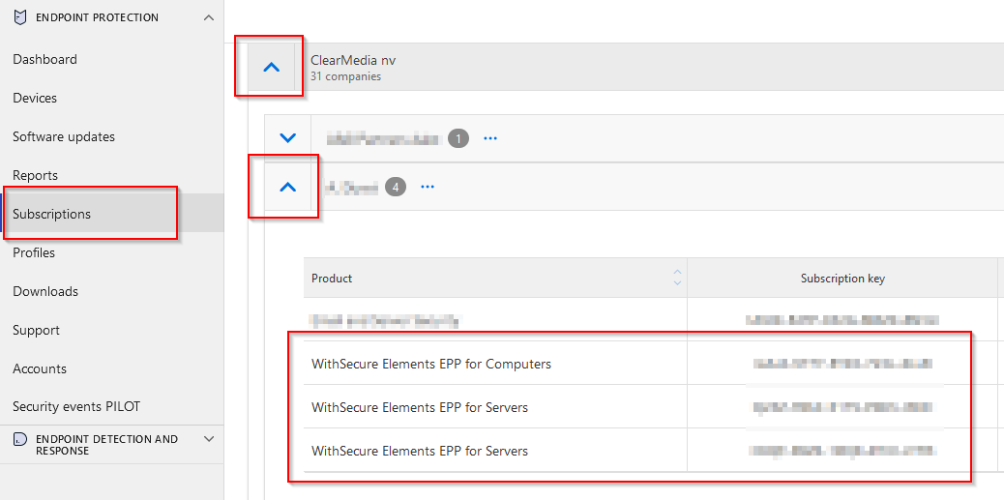

* Finish the installation of the F-Secure agent on the server.
* After completion reboot the server.
* You should now find the server in the F-Secure PSB Admin management portal.
* If you would like to configure the F-Secure agent locally, open the system tray, find the “F-Secure Elements” icon, click on it, and then click on the “Sprocket” Symbol.

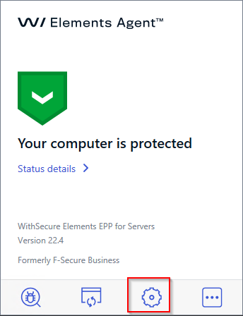

* Edit the Scanning Exclusion list by going to “Server Protection”, then “Real-Time Scanning” and then clicking on “Configure” behind “Exclude from Scanning”.

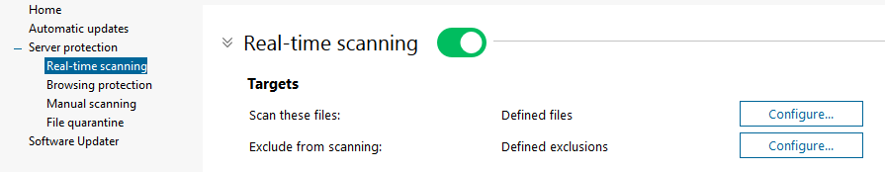

* Go to the “Objects” tab and click on “Add”. Either browse to a folder or add the folder by copy pasting it in the box above. Click on “OK” twice **AND** on “Save to Apply” below to actually save the settings.

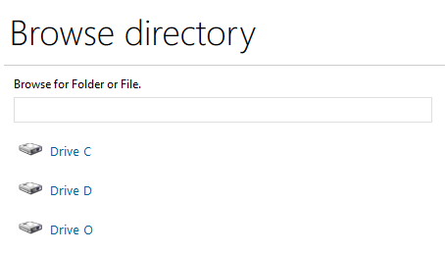

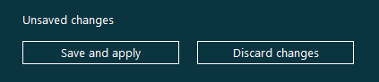

* You can also configure the policy’s via the online PSB portal. You can find this under “Profiles”.

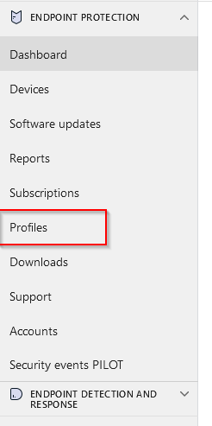

* **Finished!**

The following software requires Exclusions in WithSecure

* Kluwer
* Adsolut
* Anything MS SQL based
* FSlogix
* .VHDX files
* Windows Update Directory:: **C:\Windows\SoftwareDistribution**